**Website for coding practice**

END TERM REPORT

***By***

**VAMSI SAI KRISHNA TANINKI**

**VIKAS REDDY CHINNAM**

(Section: K19SB)

(Roll no. : 65, 26)



**Department of Intelligent Systems**

**School of Computer Science Engineering**

**Lovely Professional University, Jalandhar**

April-2020

**Student Declaration**

This is to declare that this report has been written by us. No part of the report is copied from other sources. All information included from other sources have been duly acknowledged. We aver that if any part of the report is found to be copied, we are shall take full responsibility for it.

Vamsi Sai Krishna

Roll no. – 65

Vikad Reddy Chinnam

Roll no. – 26

Date – 8/4/2020

**TABLE OF CONTENTS**

**TITLE -**  Website for coding practice **Page No. –** 3

BONAFIDE CERTIFICATE

Certified that this project report on“……….HOTEL BOOKING MANAGEMENT ……………..” is the bonafide work of “…………..TANIKI VAMSI SAI KRISHNA and CHINNAM VIKAS REDDY.…………” who carried out the project work under my supervision.

Name of supervisor - Dr. Dhanpratap Singh

ID of Supervisor - 25706

**BACKGROUND AND OBJECTIVES**

**Description :-**

**This is a web application built to help you practice programming and improve your coding skills. We offer a collection of code challenges and web development courses that can help you prepare for upcoming job interviews. The coding challenges range in difficulty and they can all be completed straight in our online editor.**

**If you are an employer, we offer a technical screening product as well which can help you recruit top talent faster and more accurately.**

**Read more about how this website can help developers get a job, practice their skills, and how employers can make the best use of this website for technical screening on our blog here.**

**Many computer programs remain in use for far longer than the original authors ever envisaged (sometimes 40 years or more), so any rules need to facilitate both initial development and subsequent maintenance and enhancement by people other than the original authors.**

**In Ninety-ninety rule, Tom Cargill is credited with this explanation as to why programming projects often run late: "The first 90% of the code accounts for the first 90% of the development time. The remaining 10% of the code accounts for the other 90% of the development time." Any guidance which can redress this lack of foresight is worth considering.**

**The size of a project or program has a significant effect on error rates, programmer productivity, and the amount of management needed.**

**Objective:-**

* Clear definition of purpose.
* [Simplicity](https://en.wikipedia.org/wiki/KISS_principle) of use.
* Ruggedness (difficult to misuse, kind to errors).
* Early availability (delivered on time when needed).
* Reliability.
* [Extensibility](https://en.wikipedia.org/wiki/Extensibility) in the light of experience.
* Brevity.
* Efficiency (fast enough for the purpose to which it is put).
* Minimum cost to develop.
* Conformity to any relevant [standards](https://en.wikipedia.org/wiki/Coding_conventions).
* Clear, accurate, and precise [user documents](https://en.wikipedia.org/wiki/User_documentation).

**Work division:-**

* Vamsi Sai Krishna:- Home page

Login pages

* Vikas Reddy:- About us page

Contact us page

Photos and icons

**PICTORAIL FLOW OF PROJECT**

Entering Password

CHECK

PASSWORD

Create Login ID

NO

YES

Home Page

About us

Contact us

Challenge-s

Solution guide

Courses

EDITOR portal

Output

NO

YES

Code checker

Errors

Solution

**SCREENSHOTS OF WEBSITE**

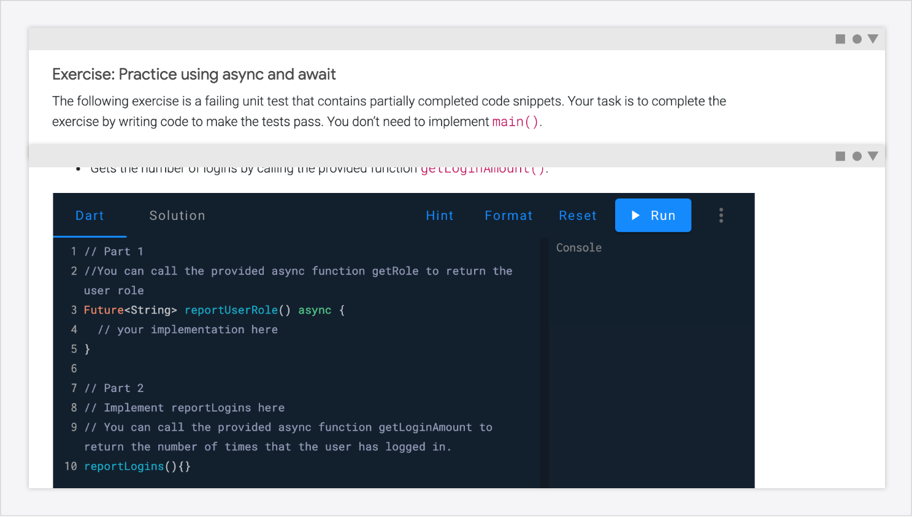Home Page

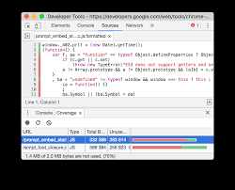

Booking details and Rooms

Login page

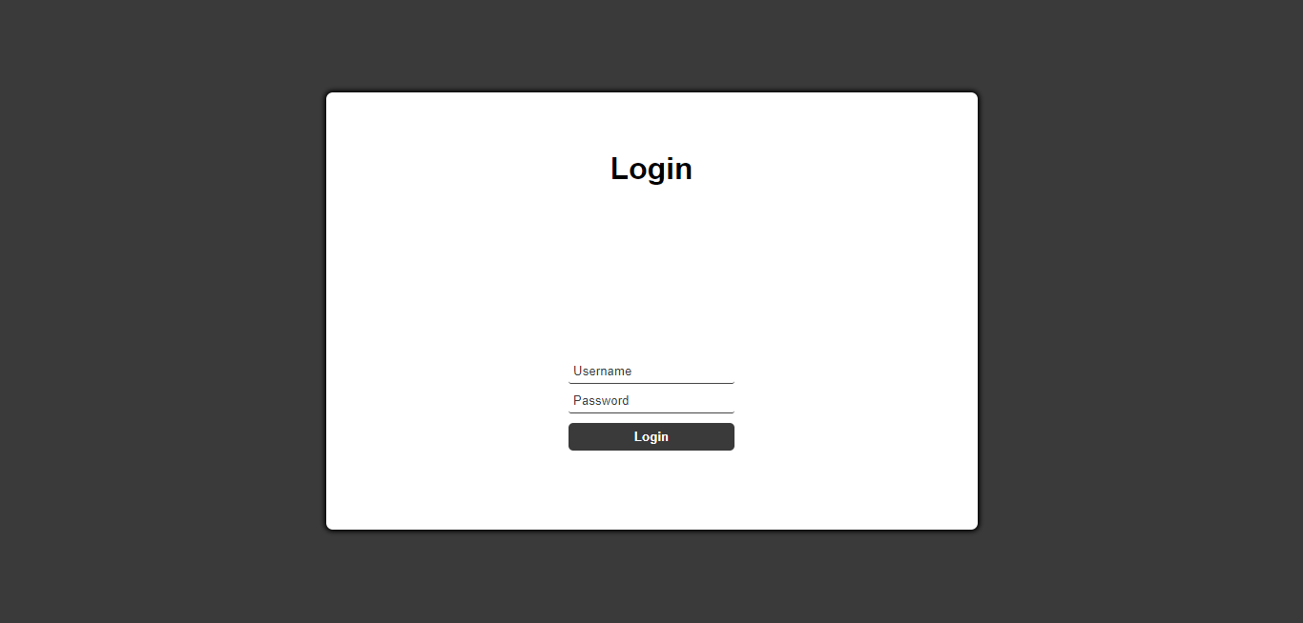

Editer portal page

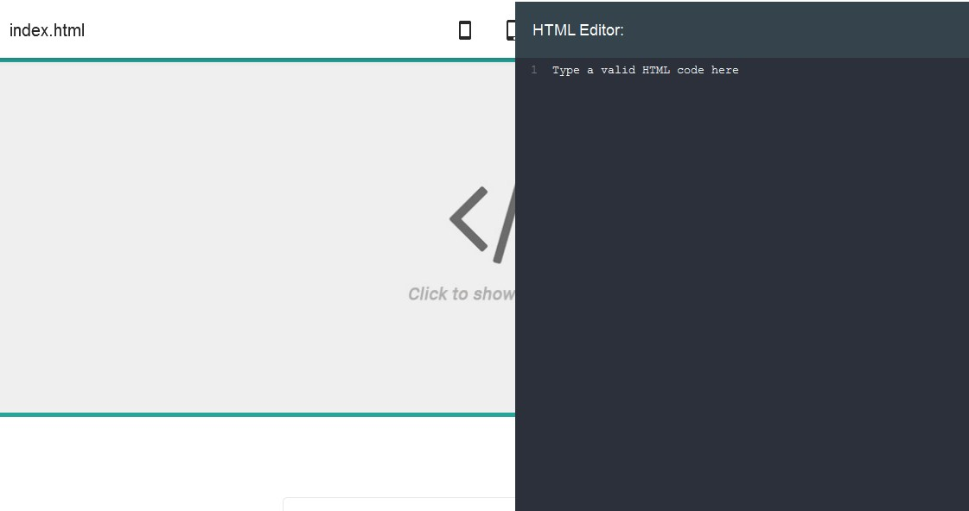

Bill payment portal

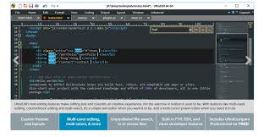

Contact us page

Our mailing address is:

PO Box 1115  
Hyderaba dVIC 3066  
India

About us page

This website is is a hub for web developers to share their passion for building incredible Internet things. Founded by Mark Harbottle and Matt Mickiewicz in 1999, SitePoint is for web professionals, *by* web professionals: developers, designers, programmers, product creators and entrepreneurs alike.

We love our rich and engaged community and our contributors, who are truly leaders in their field.

Sign up page

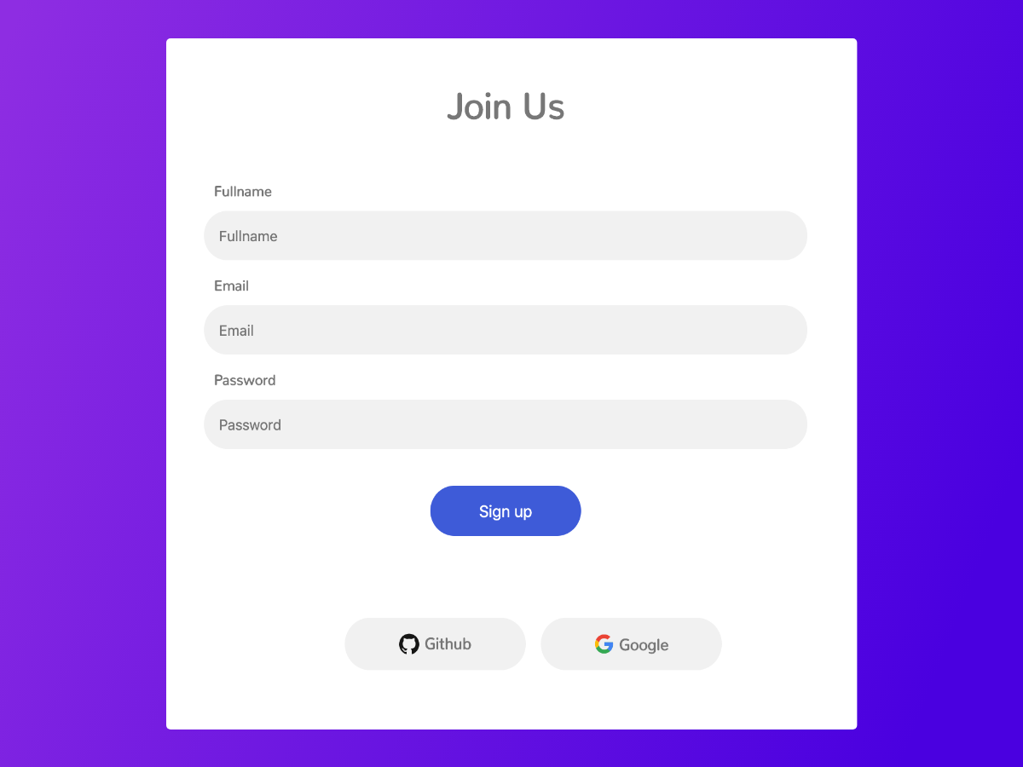

**FUNCTIONALITY**

**Computer coding is the use of computer programming languages to give computers and machines instructions on what actions to perform. Coding is the way humans communicate with machines, and it allows us to create software like programs, operating systems, and mobile apps.**

Programming languages are simply a set of rules defining how code should be written that bring machine language (those ones and zeros) closer to human language. It’s easy to think of it as a language the computer can understand.

We use programming languages to create software programs. A program is just a text file that serves as an instruction manual for a computer. When you launch an application, you’re telling the computer to read the text file and execute the commands therein.

Coding is in almost every aspect of modern life. Every application on a phone, tablet, or computer uses computer languages to run. Other digital systems like smart TVs and calculators use it as well. Virtually every new car uses it to control everything from air conditioning system to fuel injectors, and cities employ computers to oCoding is in almost every aspect of modern life. Every application on a phone, tablet, or computer uses computer languages to run. Other digital systems like smart TVs and calculators use it as well. Virtually every new car uses it to control everything from air conditioning system to fuel injectors, and cities employ computers to operate traffic signals.perate traffic signals.